**Check** **NTP Server Synchronized**

## **NTP Server:**

## **How to check NTP Server is Synchronized:**

* Open Start
* Run PowerShell as an Administrator.
* Execute the Command below:

“w32tm /query /status >>C:/Share/NTPServerSyncStatus.txt”

**Internet Time Server Network Time Computer**

**System Server**





** **

**Computer Computer**

Fig 1: NTP Server Connection

## **Evidence:**

* Local Execution with Evidence
* Open PowerShell.
* Execute below command.

**Command:**

“w32tm /query /status /verbose >>C:/Share/$(get-date -f yyyy-MM-dd)_NTP_Server_Sync_Status.log”

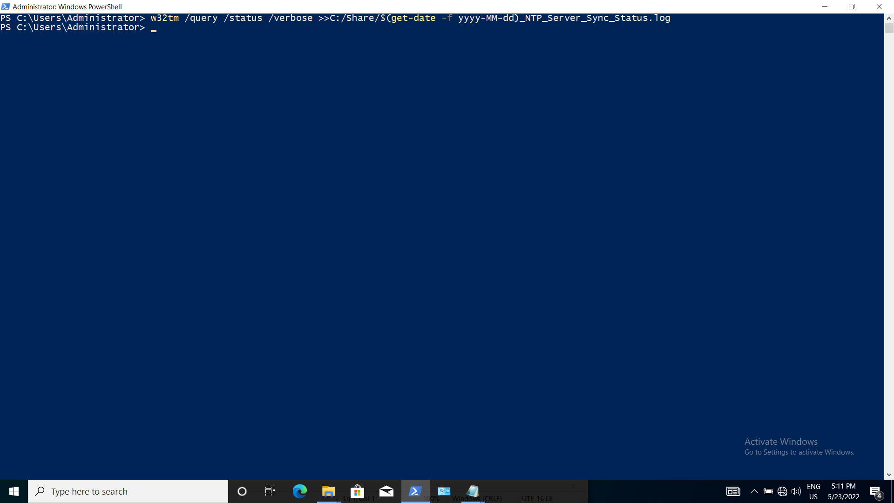

Fig. 2.1: Execution of Command on PowerShell

* Remote Execution with Evidence

Below command executed on MD system

**Command:**

python

import winrm

s = winrm.Session(‘<target_machine_ip>’, auth=(‘<user_name>’,’<password>’))

r = s.run_ps('w32tm /query /status /verbose >>C:/Share/$(get-date -f yyyy-MM-dd)_NTP_Server_Sync_Status.log')

r.status_code

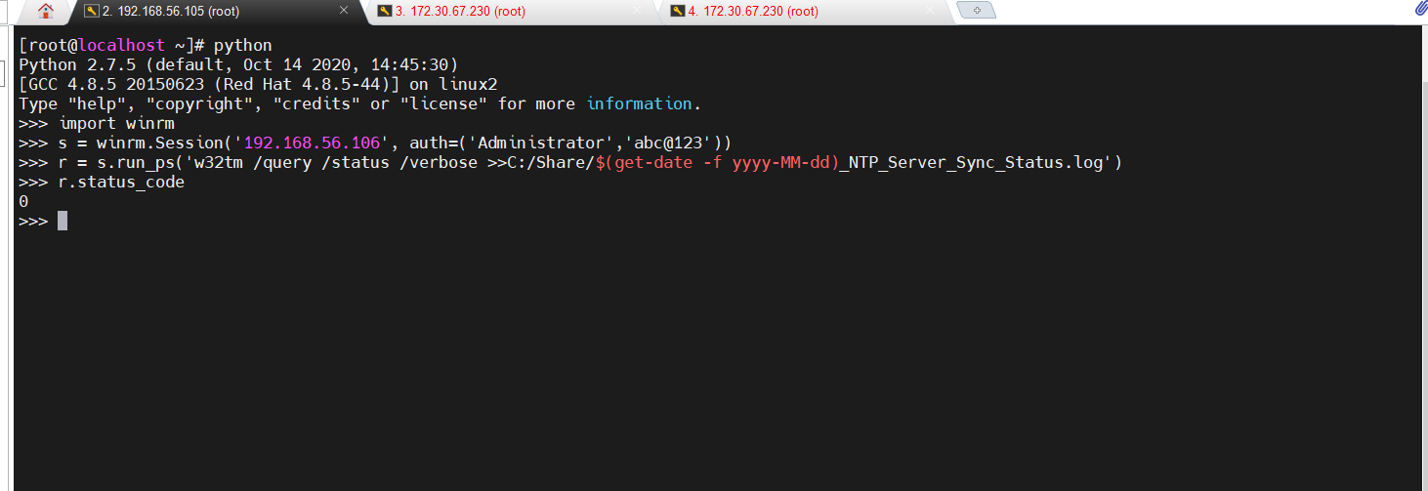

Fig. 2.2:Remote Execution on MD System Successful status evidence

## **Verification:**

* Login TS system.
* Open This PC.
* Go into local disk (C)
* Go into Share folder

“NTP_Server_Sync_Status.log” file must be there after executing below command

Command:

w32tm /query /status /verbose >>C:/Share/$(get-date -f yyyy-MM-dd)_NTPServerSyncStatus.log

Parameters Description:

* Status: This parameter ‘status’ gives the status of NTP Server whether it is Synchronized or not,
* Verbose: This parameter ‘verbose’ gives the more detail information about ntp server.

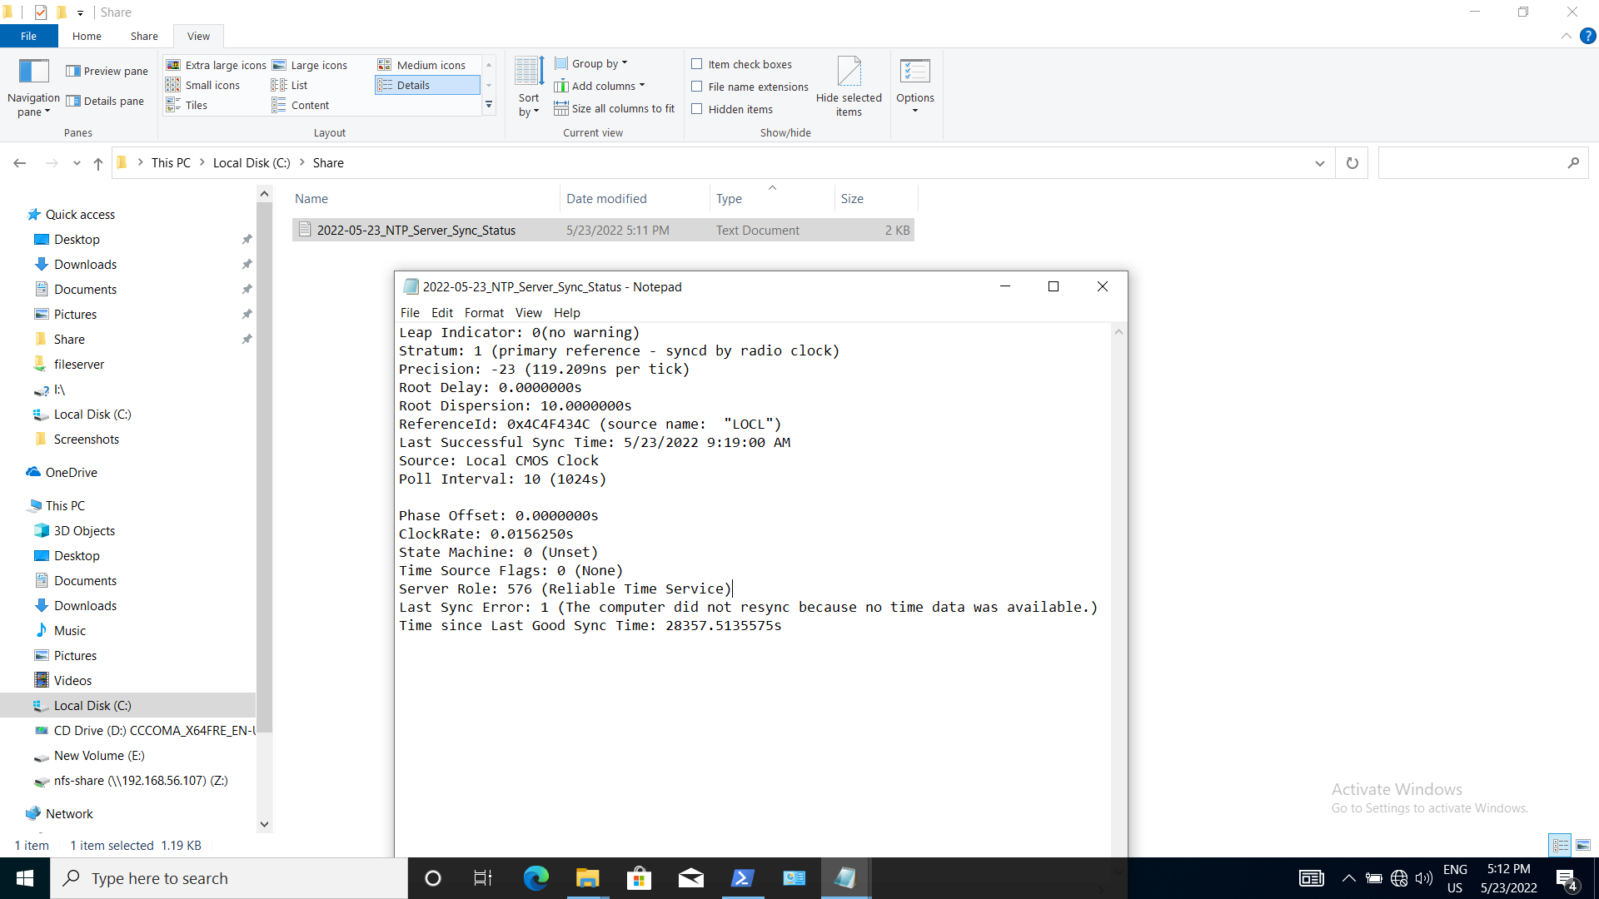

Fig 2.6 NTP_Server_Sync_Status.log created on TS system after remote execution on MD System Successful